

**Sennheiser Wins InfoComm 2025 Awards for Spectera and Profile Wireless 2-Channel Microphone System**

**Industry Honors Recognize Innovation Across Wireless Audio Ecosystems**

**OLD LYME, Connecticut — July 2, 2025 —** [**Sennheiser**](http://www.sennheiser.com)**, the manufacturer building the future of audio for 80 years, today announced that the company’s wireless audio solutions garnered three major industry honors presented during InfoComm 2025. Spectera, the company’s groundbreaking bidirectional wireless ecosystem, was named by *Mix* magazine a Best of Show winner, was the winner of the *rAVe PUBS* Best of InfoComm Award as the Best All-in-One Wireless Solution for Audio as well as being selected by the same magazine as the Favorite New Live Events Product in the 2025 Reader’s Choice Awards. Additionally, the Profile Wireless 2-Channel Microphone System received the *Systems Contractor News* Installation Product Award for Most Innovative Audio Hardware. Together, the awards highlight Sennheiser’s commitment to delivering forward-looking wireless solutions that simplify workflows while raising the bar for reliability and performance.**

Spectera is the world’s first wideband, bidirectional wireless solution for mics, in-ear monitoring, and control signals—all transmitted through a single RF channel. Its compact components, automatic frequency coordination, and simple setup are designed to streamline the most demanding live productions. The system includes bidirectional SEK bodypacks, the DAD transceiving antenna line, a modular Base Station, MADI interface options, and both desktop and web-based software control through LinkDesk and Spectera WebUI. Spectera was previously awarded Best of Show honors by *TVB Europe* magazine at both IBC 2024 in Amsterdam and ISE 2025 in Barcelona.

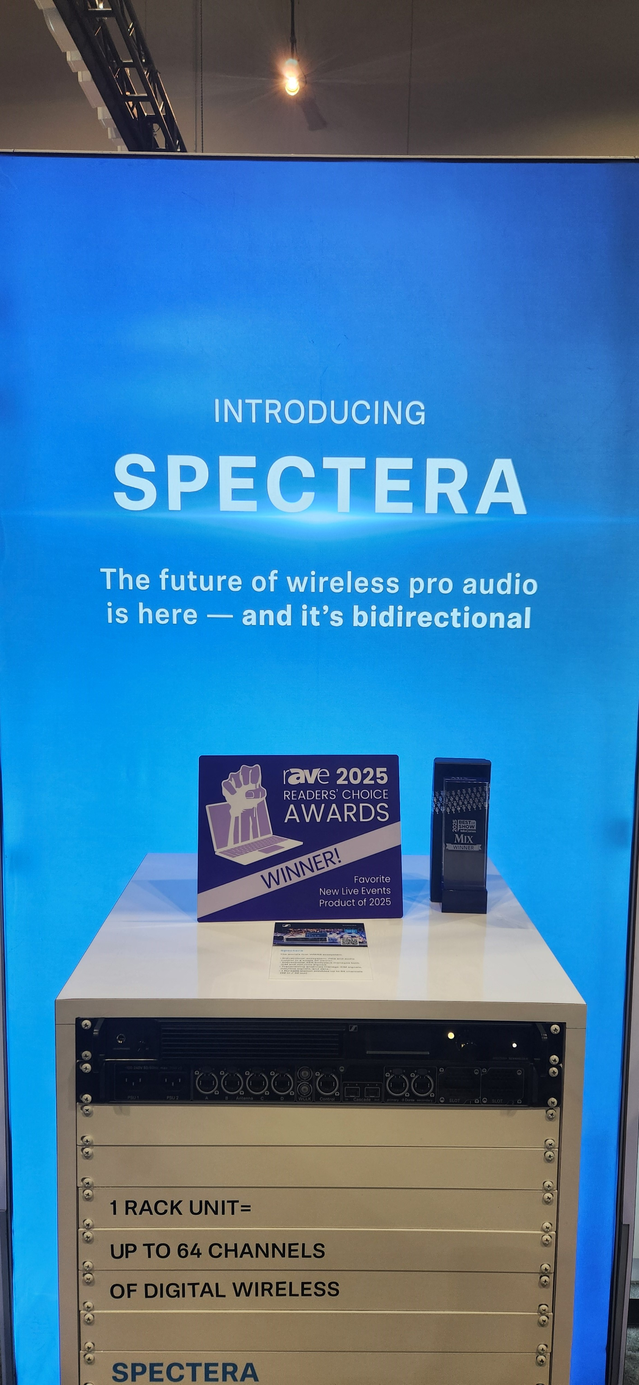

*Sennheiser’s Spectera system at InfoComm, along with its awards from Mix and rAVe.*

Sennheiser’s Profile Wireless 2-Channel Microphone System simplifies high-quality audio capture for creators, educators, and hybrid meeting spaces. Operating on the 2.4 GHz band, the system includes both clip-on and handheld transmitters, a dual-channel receiver, and a portable charging bar. Its newly added 32-bit float recording and switchable Safety Channel Mode ensure users capture clean, distortion-free audio in any environment. The system was also named a recipient of the Tipa World Awards 2025 as the best video sound accessory.

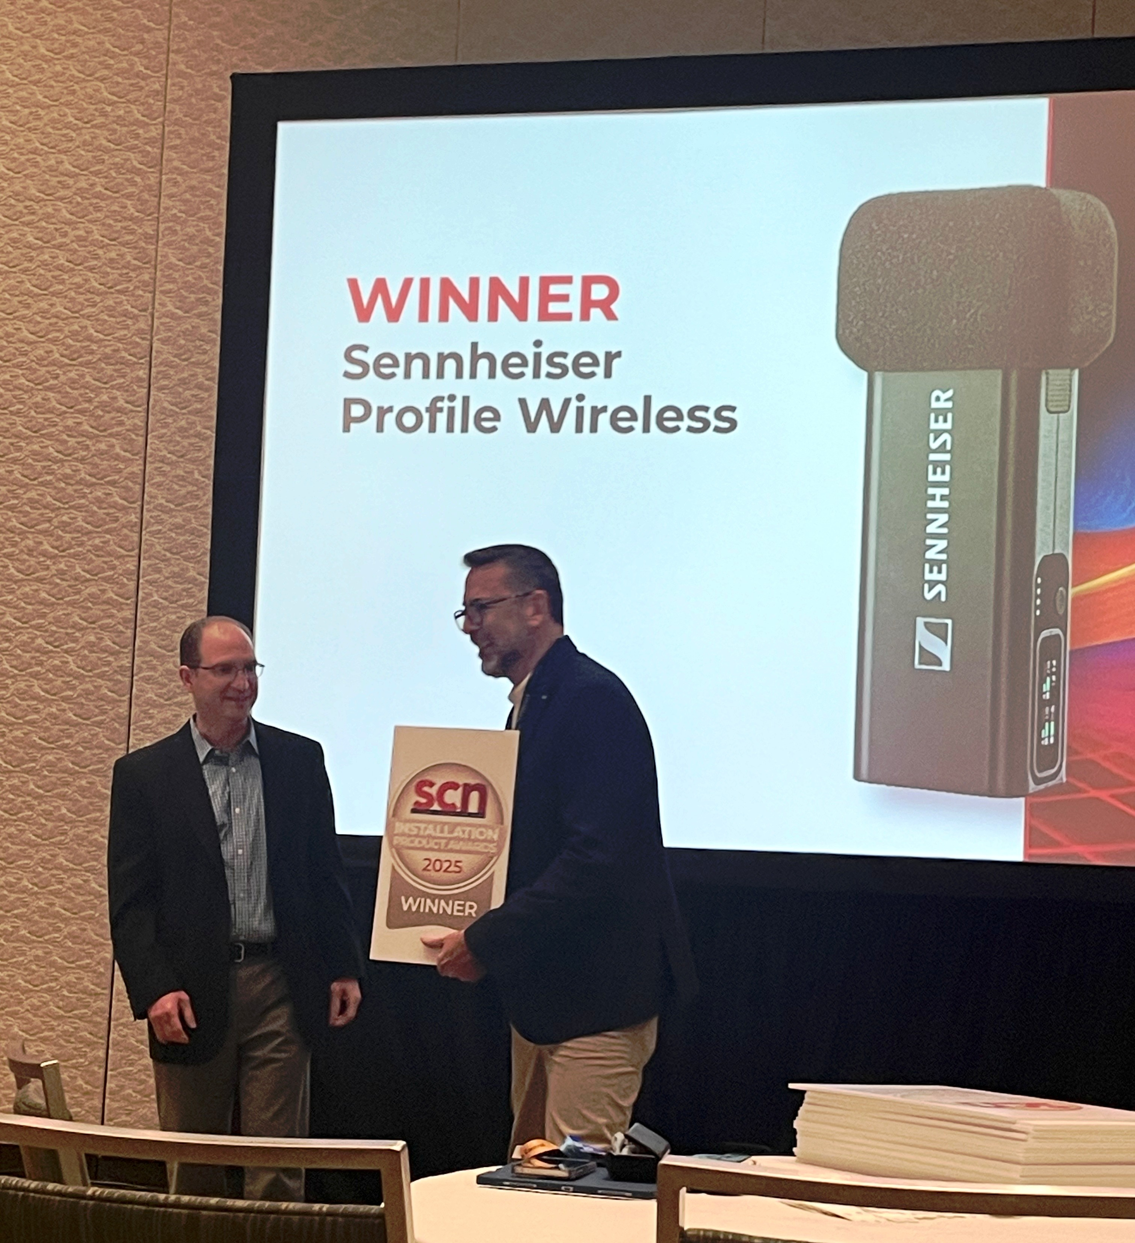

*Sennheiser’s Hugo Caballero, Trade Marketing Manager, Pro Audio, accepting SCN’s Installation Product Award for the Profile Wireless 2-Channel Microphone System.*

“These awards represent the incredible work our engineering and product teams have put into developing solutions that meet the needs of today’s pro audio professionals and creators while anticipating what’s next,” said Ed Capp, Vice President, Sales, Americas at Sennheiser. “It’s an honor to have both Spectera and the Profile Wireless 2-Channel System continue to be recognized for their innovation and impact in the industry and across the globe.”

For more details on these products and other Sennheiser innovations introduced at InfoComm 2025, visit www.sennheiser.com.

###

**About the Sennheiser brand**

We live and breathe audio. We are driven by the passion to create audio solutions that make a difference. In 2025, the Sennheiser Group celebrates its 80th anniversary. Since 1945, we stand for building the future of audio and bringing remarkable sound experiences to our customers.

Today, the Sennheiser Group is one of the leading manufacturers in the field of professional audio technology. With our brands Sennheiser, Neumann, AMBEO and Merging, we offer a comprehensive range of solutions that is fully tailored to the needs of our customers. As independent family-owned company Sennheiser is led in the third generation by Co-CEOs Dr. Andreas Sennheiser and Daniel Sennheiser.

[www.sennheiser.com](http://www.sennheiser.com)

[www.sennheiser-hearing.com](http://www.sennheiser-hearing.com)

**Local Press Contacts**

Kirsten Spruch

kirsten.spruch@sennheiser.com

+1 (860) 598-7484

Peter Schuyler

[Peter@ingearpr.com](mailto:Peter@ingearpr.com)

+1 (917) 496-8970